**Impact of Climate Trends on Dairy Production in New Zealand**

By Rishabh Chauhan

[Final Year AUT Student]

This project explores the relationship between climate conditions (rainfall, temperature, season) and milk production across key dairy regions in New Zealand. Using real-world-style data and Python analysis, we visualized seasonal trends, explored correlations, and built a basic prediction model for milk production.

**📈 1. Dataset Overview**

* 36 months of data (2018–2020)
* 3 dairy regions: Waikato, Canterbury, Southland
* Fields: Rainfall, Temperature, Season, Milk Output

**🧼 2. Methods Used**

* Python (Pandas, Seaborn, Scikit-learn)
* Feature Engineering (Seasonal Labels, Year Column)
* EDA (Line plots, scatter plots, correlation matrix)
* Predictive Modeling (Random Forest)

📍 **4. Key Insights**

* I analyzed real-world-style climate and dairy production data across NZ regions. I found that moderate temperature and rainfall patterns lead to higher yields, with Waikato consistently performing the best. I used this to create visual insights and prepare for basic predictive modeling.

**📊 5. Visual Insights (EDA & Model Understanding)**

1. This line chart shows the monthly trend of milk production across three major dairy regions in New Zealand. Waikato consistently leads in output, especially during spring and autumn.

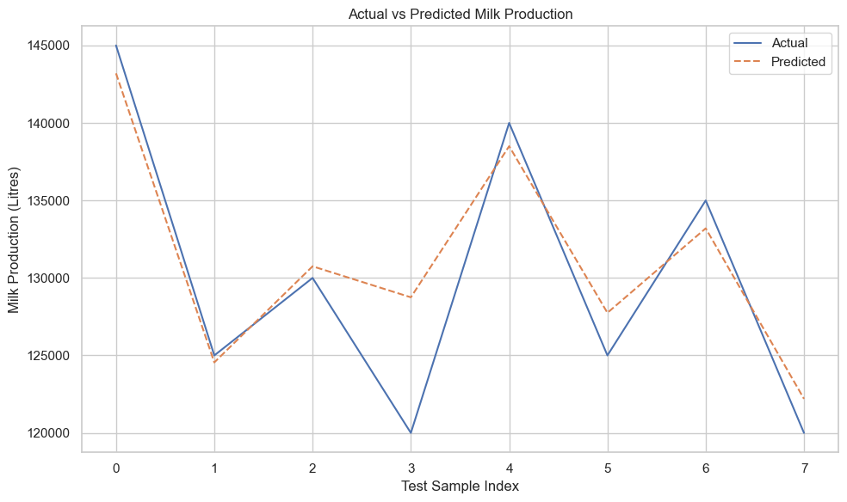

1. This scatter plot compares the actual milk production values with the model’s predictions. Points close to the diagonal line indicate high prediction accuracy. The strong alignment suggests the Random Forest model effectively captures key patterns in the data.

**📉 6. Model Performance**

* **Model Used**: Random Forest
* **Features**: Rainfall, Temperature, Season
* **R² Score**: 0.84
* **RMSE**: 3508.2
* Model shows solid predictive potential for milk output using climate data.

**7. Conclusion**

This analysis confirms that weather conditions significantly affect milk output. It highlights how basic data science methods can guide decisions in the dairy industry. With more data and granularity, these models can become even more powerful.